Roderick Fisher

CS-405-X6165

July 2, 2023

Numeric Overflow Coding

Screenshot of console output: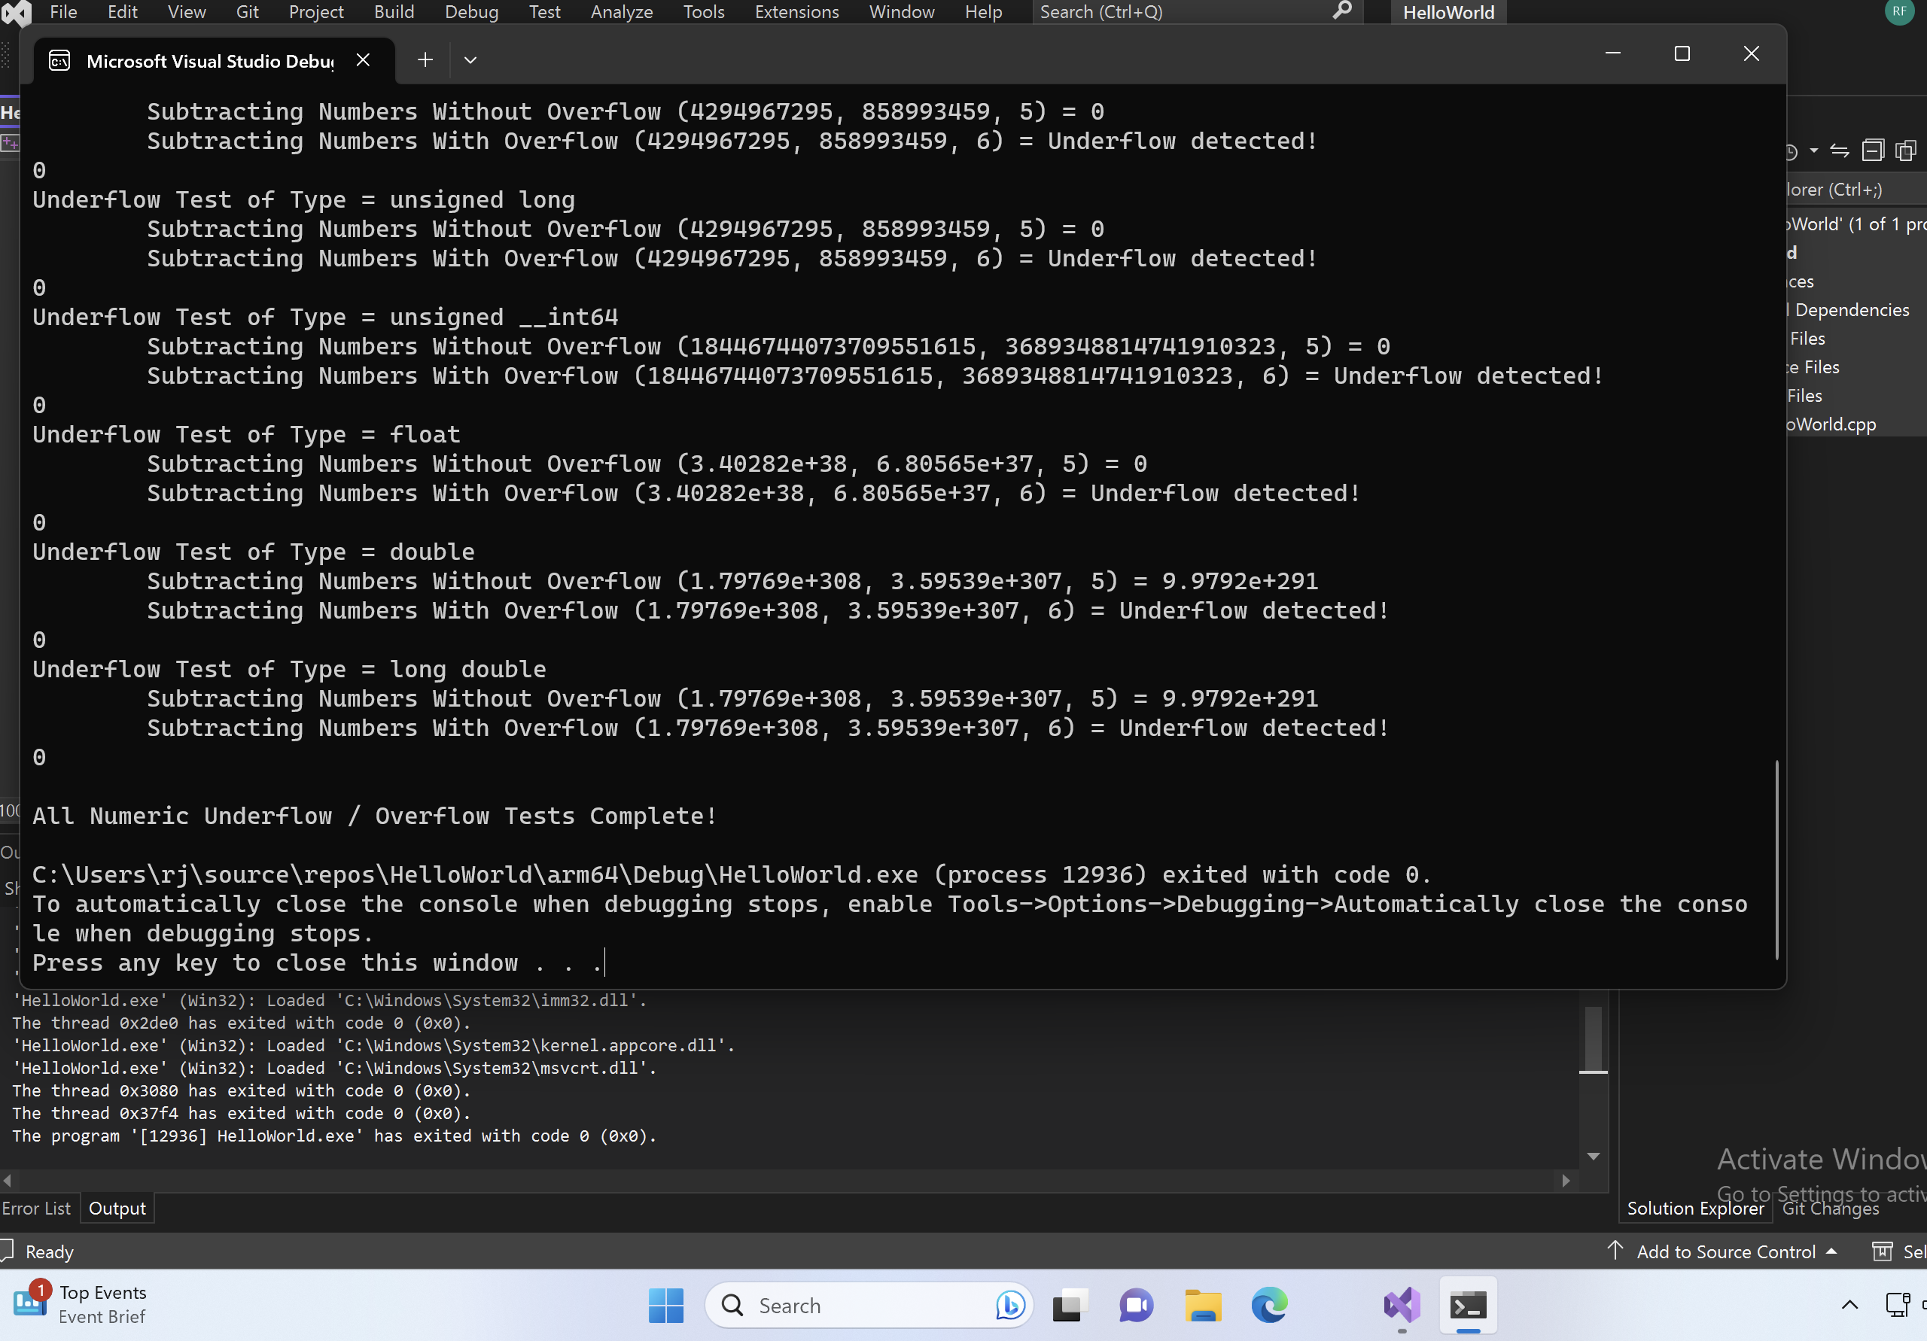

I made a few changes to the code to meet the requirements for secure handling of numeric overflow and underflow. In the ***add_numbers*** template function, I added a check to detect if an overflow would occur during addition. If an overflow was expected, I skipped the addition operation and returned a special value, like the maximum value of the data type, to indicate that the addition failed. I made similar modifications to the **s*ubtract_numbers*** template function to handle underflow. If an underflow was detected, I returned a designated value, such as the minimum value of the data type.

I also adjusted the***test_overflow***and ***test_underflow*** functions to account for the changes in the template functions. These functions now checked the return values of the respective template functions to identify any overflow or underflow situations. If an overflow or underflow was detected, I displayed a message to inform the user about it. In cases where no overflow or underflow occurred, the functions displayed the calculated result as they did originally.